Creating Calm Classrooms
Facilitator’s Guide
A SAPPIN Training for Teachers to Help Create Calm Classrooms in the Midst of the COVID-19 Pandemic

MODULE 2 (1 hour)
Note to facilitators: This process was designed for online training to accommodate the Covid pandemic. However, it is adaptable to face to face.
CCC Module 2 Powerpoint should accompany this module.
Materials needed for online training : Emotions Faces.
CCC Module 2 powerpoint
“Calming activities for CCC” document.
CCC pamphlet.
Evaluation form
M&E: Post-test form to be sent one week after the training.
Follow up: Suggested key messages to gently remind participants about the learning and to encourage and support practice of calming techniques. Use WhatsApp broadcast group or WhatsApp business to disseminate messages.

Materials needed for face to face training: CCC Module 2 powerpoint, either projected from computer via data projector OR print visual slides out large and in colour so that participants can clearly see images relevant to this training. Alternatively, the powerpoint can be sent to participants via email/whatsApp.
“Calming activities for CCC” document.
Evaluation form
M&E: Post-test form to be sent one week after the training.
Follow up: Suggested key messages to gently remind participants about the learning and to encourage and support practice of calming techniques. Use WhatsApp broadcast group or WhatsApp business to disseminate messages.

Activity | Description | Time
Welcome and “check-in” | How are you feeling after the last module? Any thoughts, feelings or follow ups you’d like to share? | 10 mins
Activity 2.1: Experiential Calming Exercise | Facilitators again pick any of the calming activities that they feel comfortable with and facilitate that activity. Alternatively, a volunteer facilitates an experiential calming exercise. Again the “emotion faces” card can be used, to help with reflection on how the activity impacts on feeling states. (Emotions faces card on page 11 of this Facilitator’s Guide and on powerpoint). For each activity, before it is started, the facilitator should ask the participants to look at the emotions faces and pick a word that best describes how they are feeling right now. After the activity, the facilitator should ask participants to repeat looking at the card and choosing a word that best describes how they are now feeling. Participants should be encouraged to add their own words to the bottom of the card should they wish to. If there is time – they can share with a fellow participant or write it in the zoom chat if they want to.  Alternatively, if you don’t wish to use the emotions faces, simply ask participants to think in silence for a short while about how they are feeling in the moment. | 10 mins
Activity 2.2: Trauma vs. Stress | See powerpoint slides for visuals.  Stress and trauma are related, but they are not the same. Every trauma is a crisis and induces stress. But not all stress is trauma or crisis. We will unpack each term a little more. It is important to examine the difference so that we understand our responses to what we experience when we are stressed or traumatised.  Stress  Stress is defined as: a state of mental or emotional strain or tension resulting from adverse or very demanding circumstances. (Oxford Dictionaries online).  Synonyms for stress are strain, pressure, tension… do these sound familiar?! Many educators have been living under enormous amounts of strain, pressure and tension during the months since coronavirus came to South Africa. Many were already living under that sort of stress before, and the pandemic has amplified the stress.  It is very normal and even beneficial to have a certain amount of stress in our lives. However, when many stressors pile up and the individual has few or no resources to call on, this can eventually lead to a crisis where one is completely overwhelmed. This is a point at which ‘burnout’ can occur.  Trauma  Trauma is an intense, often overwhelming event or series of events that a person has experienced or witnessed or been confronted with. This includes accidents, sexual assault, domestic violence, exposure to crime and all types of violence. These events leave the person feeling disconnected from others and disempowered or helpless. Traumatic events are often life changing. It is important to note that the event does not have to happen to you directly, but it could have happened to a loved one and told to you, resulting in traumatization to yourself.  Stress-Trauma Continuum  Stress Crisis Trauma  Normal responses to trauma and stress  Our responses to both trauma and stress can look quite similar in many ways. For both stress and trauma, our threat system in the brain is activated, your body can become flooded with stress hormones, and it can take a while to regain your calm/’safeness’ state.  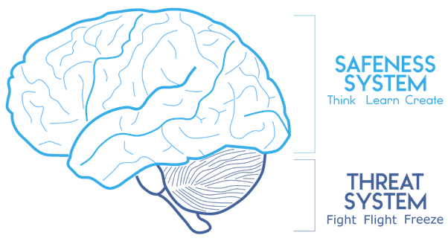  A normal stress response of acute (short term) stress is less intense than a normal trauma response. When the stress is chronic (ie: ongoing), the normal response can more closely resemble that of trauma.  Intense experiences such as nightmares and flashbacks, intense intrusive thoughts and avoidance behaviours are more closely linked to a trauma response. (See Normal Trauma Response below).  Normal Trauma Response (adapted from Sinani’s Handbook for Trauma Support Workers) (on powerpoint slide)  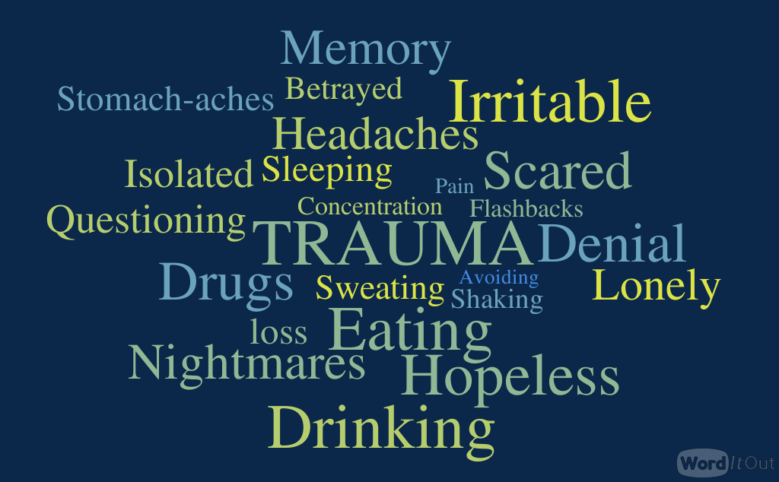  Red Flags: When to seek professional help – for yourself or learners 🔺🔺🔺  Ask participants when they think they should seek professional help – listen to ideas.  Add the following (on power point slide), if they have not already been mentioned.  🔺When in a situation of ongoing danger. This can include domestic violence, and abuse. A sense of safety is essential to activate the safeness system of the brain and to contribute to cultivating calm that allows creativity, growth and learning to occur, as well as connection with others. Help is available, keep on seeking help until you find it.  🔺When there has been a trauma and symptoms (normal trauma responses as above) persist for longer than a month with no relief, or are getting worse.  🔺When there has been rape or sexual assault. Always seek help, as soon after the incident as possible.  🔺When you feel that you can no longer move forward – it feels as though you are ‘stuck’ in the trauma or the stress that you’re experiencing.  🔺When you are using negative coping mechanisms on an ongoing basis, such as excessive alcohol use, drugging, or any other addictive behaviours.  🔺In learners, when you see a change in behaviour such as becoming withdrawn and silent or more aggressive and ‘acting out’, or falling behind in school work; take note and address your concerns calmly with the learner directly where appropriate. Tell them what you have noticed and ask them how you can help. With adolescents, you may be able to come up with a plan together. With younger children, you can express your care and concern and plan to speak to their caregivers.  🔺Increased absenteeism in learners.  Key Message: Help is available. Resources for referral: see numbers on pamphlet.  Brainstorm with the group appropriate referral resources particular to their area. | 20 mins
Activity 2.3: Being the Container | Share the images on the powerpoint of the angry person.  Group discussion  What do these images communicate to you as you look at them?  What feelings do they stir up?  What do you imagine this person’s voice sounds like, as her face looks like this?  Which system (threat or calm) do you think is activated in the person? And if the person were shouting at a child, which system (threat or calm) would be activated in the child?  Information input  Children have all of the same feelings that we as adults do. While young children especially are very sensitive to loud noises and signs of aggression, all children and even us as adults react adversely when others show aggression and/or shout. Aggressive facial expression and tone of voice activates the threat system.  Reflect  Think about a time you had someone being aggressive towards you, think about their facial expression and their tone of voice. Reflect on how it made you feel. Reflect on how you reacted. Maybe you became defensive and aggressive back to that person. Maybe you ran away as fast as you could. Maybe you could not move and didn’t know what to do next. This was your threat system being activated.  How did the encounter leave you feeling about yourself?  How long did it take to recover a sense of balance/feeling normal again?  Share the warm image of the person on the powerpoint slide.  Group Discussion  What does this image communicate to you in contrast to the first two?  Can you remember an encounter with someone who showed care to you through their facial expression and tone of voice recently? How did that encounter leave you feeling?  This encounter would have helped to soothe you, to activate your safeness or calm system in your brain.  Facial expression and tone of voice is key in setting up a calm classroom. (Remember that over 70% of communication that occurs between people is non-verbal.)  Reflection: Reflecting on your facial expression and tone of voice for the classroom  Remember the video we asked you to take of yourself “teaching”? When this session is over, go back to that video and review it. When you look at it, what do you see? What do you see being communicated through your facial expressions and tone of voice?  Any reflections right now? Group discussion (time permitting).  Something to discuss: Many teachers may be concerned that they will lose their authority over their class if they are too soft in their facial expression or tone of voice. Brainstorm with participants how to be firm but kind in the classroom. Communicate authority and appropriate boundaries while providing calm containment. This may take some practice. Each class dynamic is different.  Input  We acknowledge, being a calm container, using warm facial expression and tone of voice is not always easy. “The way to develop a calm adult presence is through practice.” (Levine & Kline, 2008: 16). For some who have challenging behaviour to contend with in the classroom, it may take a whole lot of practice.  Your self-awareness and self-care are vitally important in this process of becoming a calm container.  You need to attune to your own sensations, rhythms and emotions, and then you will be able to attune to your children’s and become their calm container. This is why we are practicing the calming strategies together in the training. We are practicing the self-awareness and self-care in order to grow our own calm state. | 20 mins
Activity 2.4: Experiential Calming Exercise | Facilitators again pick any of the calming activities that they feel comfortable with and facilitate that activity. Alternatively, ask a volunteer to facilitate an experiential calming exercise.  Option 8: Your peaceful place (this is simply a suggestion, any calming activity can be used).  Facilitator uses steps 1 – 5 (in Breathing to 10 exercise) to get trainees into a calm space. Then facilitator continues with the following instructions:  1. Imagine you are going on a walk in the country. You are walking by yourself on a path. You can hear the birds around you and feel the sun on your back. You can smell the fresh country air. You see the green hills around you and the flowers in the grass.  2. The path begins to descend. Your steps get slower as you carefully step down, down, down into the shade of big trees.  3. You continue to step down into a forest.  4. You become aware of a small stream flowing through the forest.  5. You find a spot where you can comfortably sit with your back against a tree.  6. You listen to the sounds of the water and the birds and the leaves blowing in the breeze.  7. You allow yourself to relax there for a few moments.  8. When you are ready, you climb back up the path into the sunshine, and you gently open your eyes. | 10 mins
Closing | Thank everyone for their attendance and participation.

Emotions faces
Happy | Sad | Angry | Sick | Afraid
Tired | Confused | Hurt | Surprised | Bored
Refreshed | Down | Calm | Rejuvenated | Upset
Distracted | Frustrated | Panicked | Excited | Distressed
Rattled | Relaxed | Curious | Annoyed | Anxious

