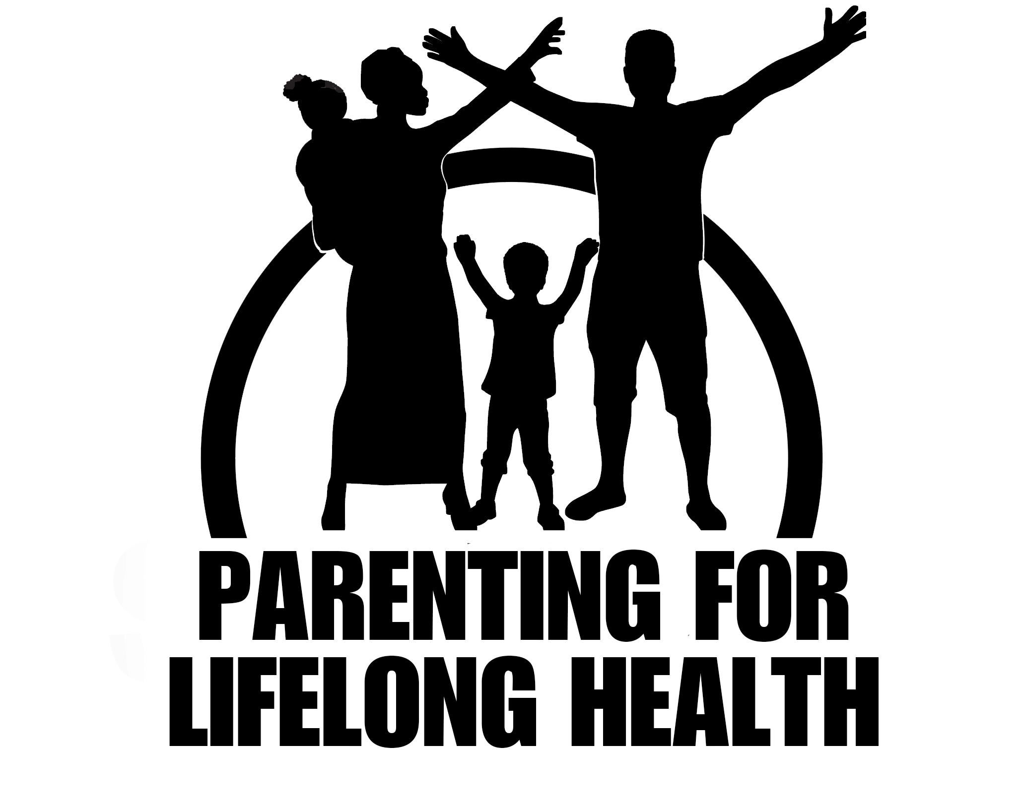

PARENTING FOR LIFELONG HEALTH PROGRAMMES

Introduction

Research and evidence base
Parenting for Lifelong Health for Young Children Ages 2 to 9 (PLH for Children) and Parenting for Lifelong Health for Parents and Adolescents Ages 10 to 18 (PLH for Teens) have been rigorously tested in South Africa by academic partners from the Universities of Oxford and Cape Town [1, 2].
PLH for Teens has been tested in rural South Africa through qualitative research in 2012 (N=100), pre-post tests and qualitative research in 2013 (N=60) and 2014 (N=230), as well as a cluster randomized controlled trial (RCT) in 40 rural and urban communities in 2015-2016 (N=1100) [3]. The immediate post-intervention results from the RCT demonstrated that families who received the programme reported lower abuse and corporal punishment, improved positive parenting, more involved parenting, and less poor supervision. Caregivers reported reductions in corporal punishment endorsement, mental health problems, parenting stress and substance abuse, as well as increases in social support. There were no reported decreases in neglect and inconsistent discipline. Adolescents reported no differences in mental health, behaviour or community violence, but had lower substance use. Intervention families had improved economic welfare, financial management, and more violence avoidance planning. No adverse effects were detected.

PLH for Children was tested in a small-scale RCT in Cape Town in 2014, which showed significant improvements in observed and self-reported positive parenting behaviour for families who participated in the programme in comparison to families who did not participate. However, the intervention group also had significantly less observed positive child behaviour compared to controls [4]. Parent self-report data from a larger RCT in Cape Town also showed increases in positive parenting, reductions in parents viewing their children’s behaviours as problematic, and decreases in harsh parenting immediately after the programme [5]. Observational data showed that parents in the intervention group, compared to those in the control group, used significantly fewer negative parenting strategies one year after the programme. Also, parents who did not receive the parenting programme were observed to use significantly less positive parenting strategies than those who received the programme at both post-test and follow-up assessments. Observed child positive behaviour decreased significantly more for children whose parents did not receive the programme in comparison to those who did receive the programme at one-year follow-up. There was no difference between the intervention and control groups in other child and parent outcomes. No adverse effects were detected.

References
[1] Ward, C.L., et al., Parenting for Lifelong Health: From South Africa to other low-and middle-income countries. Early Childhood Matters: Responsive Parenting: A Strategy to Prevent Violence, 2014. 49.
[2] Cluver, L., Meinck, F., Steinert, J. I., Shrenderovich, Y., Doubt, J., Lachman, J. M., . . . Nocuza, M. (2018). Parenting for Lifelong Health: A pragmatic cluster randomised controlled trial of a non-commercialised parenting programme for adolescents and their families in South Africa. BMJ Global Health, 3(1)
[3]..Cluver, L., et al., A parenting programme to prevent abuse of adolescents in South Africa: Study protocol for a randomised controlled trial. Trials, 2016. 17(1): p. 1.
[4]..Lachman, J.M., et al., Pilot randomized controlled trial of a parenting program to reduce the risk of child maltreatment in South Africa. Child Abuse & Neglect, 2017. 72, 338-351.
[5]..Ward, C.L., et al., Preventing child maltreatment and child conduct problems in South Africa: A randomised controlled trial of the Sinovuyo Caring Families Programme. Presentation to the University of Cape Town Department of Psychiatry and Mental Health. May, 2017: Cape Town, South Africa.

Research materials on the testing and evidence base of the PLH programmes are available on the WHO website via the following link:
www.who.int/violence_injury_prevention/violence/child/plh_timeline/en/

